- Buyer will log into the session Enquiry in Progress.
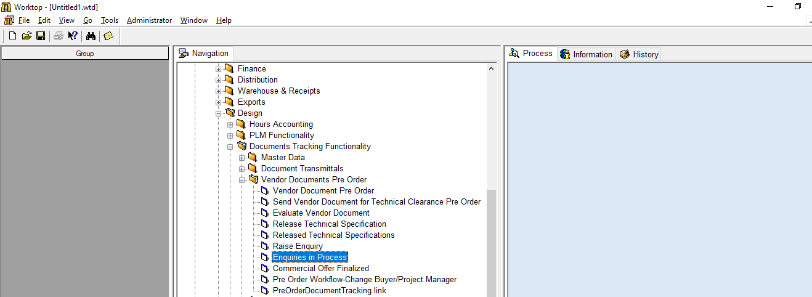
Click here

- Select view enquiry in the screen that opens up.
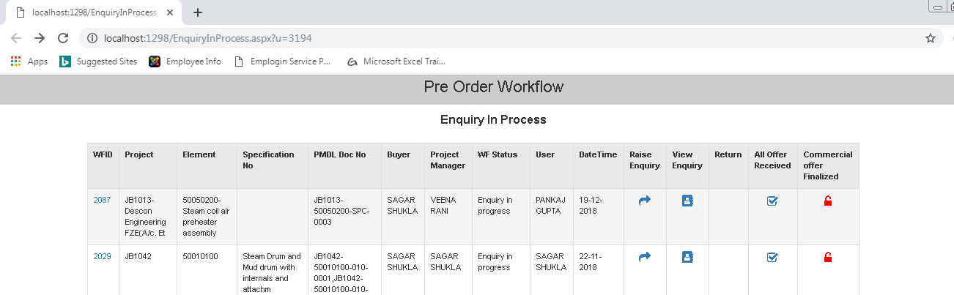
Click here

- Select WFID.
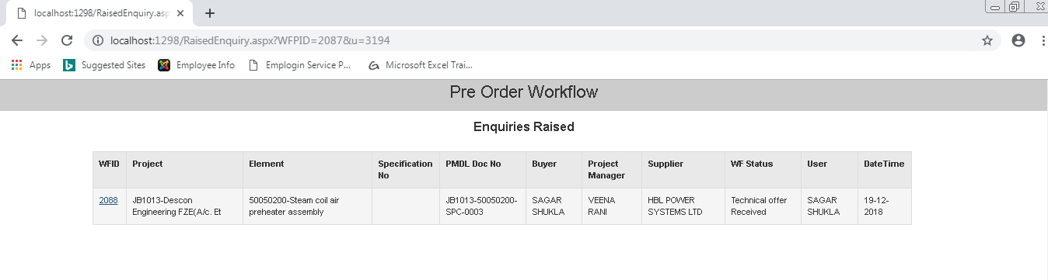
WFID

- Select on Techno Commercial Negotiation Completed for Enquiry in the screen that opens up.
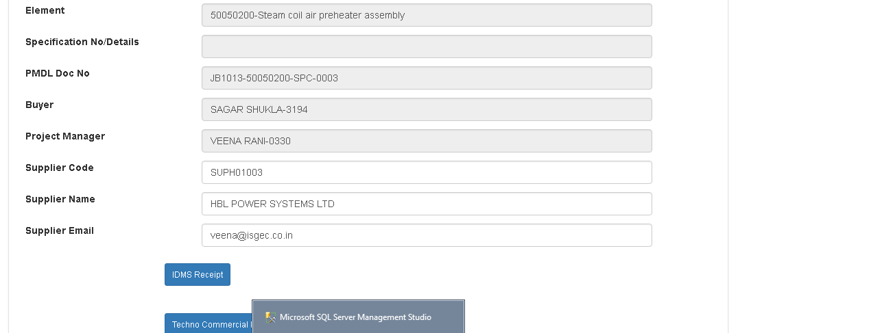
Click here
The status will change to Enquiry for techno commercial Negotiation Completed

